Wrapper Methods on the UCI Obesity Survey
Short name: WrapFS_Obes · Python / mlxtend + scikit-learn · n = 2,111 · 18 predictors + NObeyesdad

Problem Statement
A 2,111-row eating-habits survey (Palechor & de la Hoz, UCI) encodes 18 items — meals, activity, alcohol, and primary transport — plus a binary obesity flag (prevalence 46%). The teaching task is to predict obesity with logistic regression and then ask whether a wrapper can retire most of the questionnaire without giving up accuracy. Three wrappers are required: sequential forward selection, sequential backward selection, and recursive feature elimination. The operational question for a survey shop is simple: how many items do we still need?

Solution Strategy
Fit LogisticRegression(max_iter=1000) on all 18 columns and store the resubstitution accuracy. Run mlxtend SFS (k = 9 and the published k = 6), SBS (k = 7, floating on/off), and sklearn RFE after StandardScaler (n = 8 and n = 6). Compare names and scores. Cross-check with sklearn SequentialFeatureSelector, an L1-logistic embedded screen, and a mutual-information filter. Stress-test with a 70/30 hold-out, a k-sweep, and a Monte-Carlo over subsample size, label noise, and junk columns.

Solution
Model | k | In-sample acc | Stable members
All features (baseline) | 18 | 0.766 | —
SFS (starter k) | 9 | 0.784 | Age, fam. hist., FAVC, CAEC, SCC + FAF, Gender, Bike, Walking
SFS (published k) | 6 | 0.769 | Age, fam. hist., FAVC, CAEC, SCC, FAF
SBS / SBFS | 7 | 0.764 | Age, fam. hist., FAVC, FCVC, CAEC, SCC, Public_Transportation
RFE scaled | 8 | 0.768 | Age, fam. hist., FAVC, FCVC, CAEC, SCC, Automobile, Walking
RFE scaled | 6 | 0.758 | Age, fam. hist., FAVC, CAEC, SCC, Automobile
SFS-9 is the only wrapper that clearly beats the full card in-sample. The five-item core {Age, family_history_with_overweight, FAVC, CAEC, SCC} appears in every method. The SFS curve flattens at k = 8–10 (≈ 0.7835); k = 6 already matches the 18-feature model.
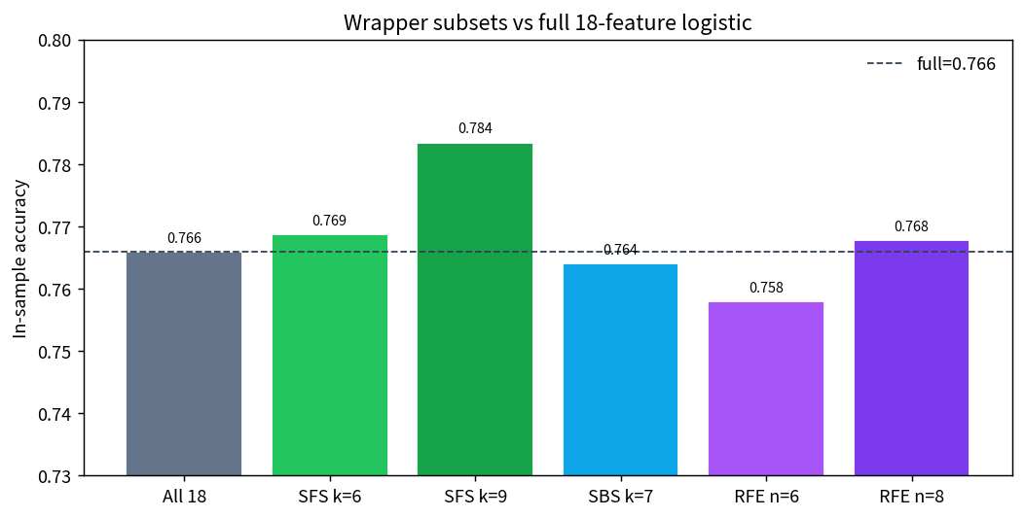
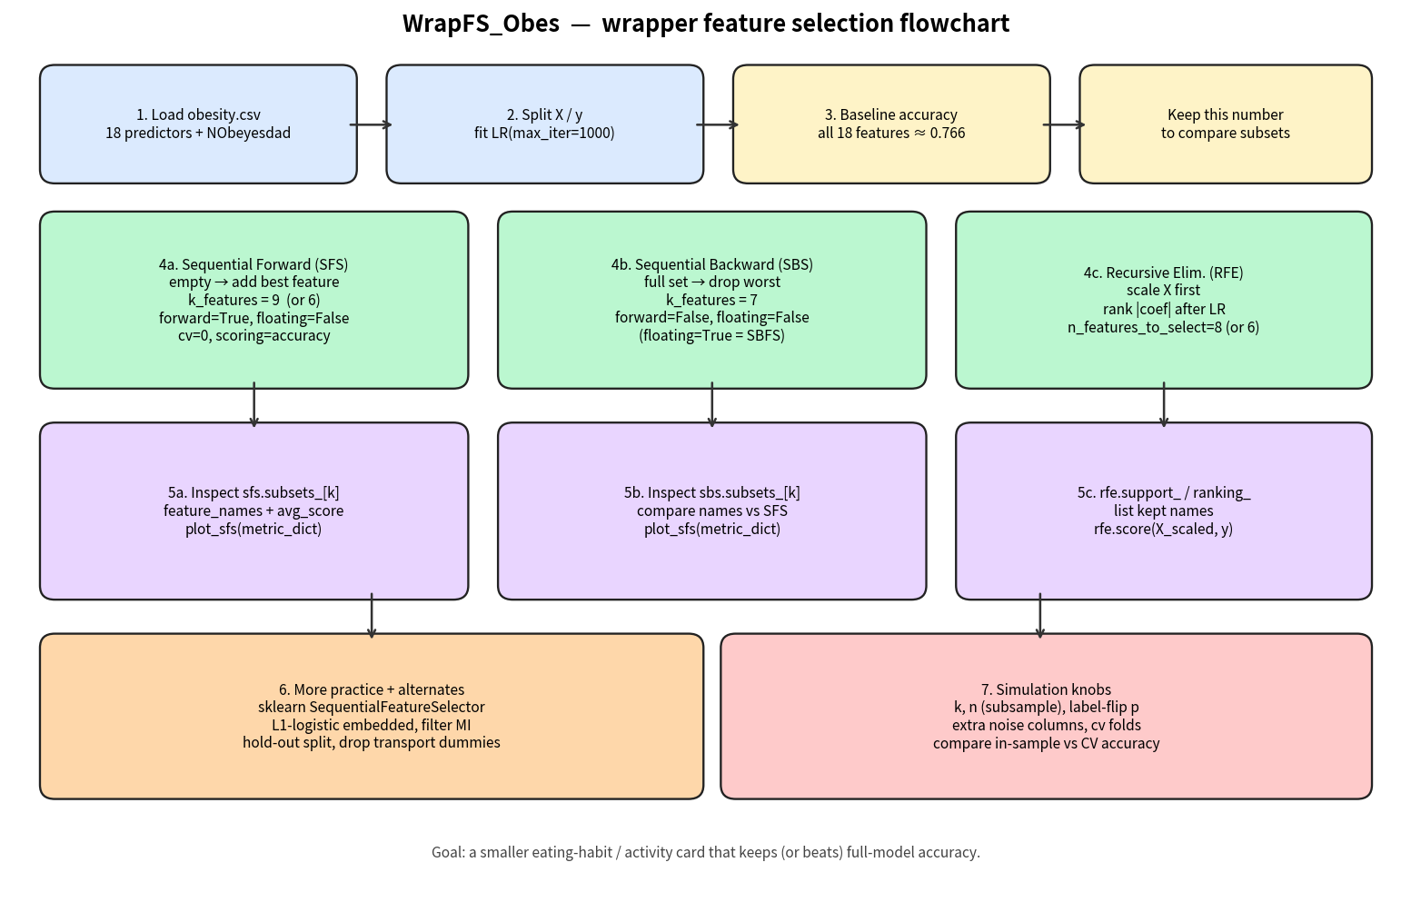

Key Takeaways
1. Wrappers wrap one estimator. A tree or a penalized model can keep a different card.
2. Greedy is not a guarantee: SFS-9 gains 1.8 pp; SBS-7 loses 0.2 pp versus all 18.
3. RFE ranks |coef| — scale first. SFS/SBS rank accuracy, so raw units are acceptable.
4. cv=0 is a resubstitution score. A 70/30 split shrinks the SFS edge; report that number before retiring questions.
5. This is a teaching survey model, not a diagnosis and not a causal claim about snacking or transport.

